**Heaven’s Light is Our Guide**



**Rajshahi University of Engineering and Technology**

**Department of Computer Science and Engineering**

**Course No:** CSE.1202

**Course Title:** Sessional based on CSE.1201 (Data Structure)

**Lab Report No:** 01

**Lab Report On:** Complexity of Algorithms

**Submitted By** **Submitted To**

Md. Ariful Islam Rizoan Toufiq

Roll No: 1803046 Assistant Professor

Section: A Dept. of CSE,RUET

Department: CSE

**Problem No:** 01

**Problem Statement:** Implementation of the Following Class

user

|  |
| --- |
| char rocket_id [14] ;  char pass [10] ;  long int balance ; |
| user (char[],char[],long int );  Number (int,int);  void topup (int );  void withdraw (int );  void balance_inquiry ( ); |

**Theory :**

**Class** is a user-defined type or data structure declared with keyword class that has data and functions as its members whose access is governed by the three access specifiers private, protected or public.

In this problem we useed a class named “User” to create a mobile banking program. The class had 3 private variables : 2 character type arrays that contained **ID** and **Passward** and 1 long integer type variable that contained **Balance** of the user.

We used 1 **constructor** that would initialize 1 user’s ID,Passward and Balance.

We used 2 **mutator** : one of these was to **topup** money and another one was to **withdraw** money. One must keep Tk. 500 in his/her account. In case of withdrawing,if the amount entered by the user was so big that there would be less than Tk. 500 in the account,the withdraw would be postponed and a message would shown like “**Insufficient Balance**”.

We used 1 **accessor** that would show the **ID** and **Current Balance** of the user.

**Source Code :**

1. main.h

|  |
| --- |
| #include <iostream>  #include "user.h"  #include<string.h>  using namespace std;  int main()  {  char id[20],pass[10];  long int balance;  cin>>id;  cin>>pass;  cin>>balance;  user u1(id,pass,balance);  u1.balance_inquiry();cout<<endl;  u1.topup(2000);  u1.balance_inquiry();cout<<endl;  u1.withdeaw(5000);  u1.balance_inquiry();cout<<endl;  u1.withdeaw(10000);  u1.balance_inquiry();cout<<endl;  return 0;  } |

1. user.h

|  |
| --- |
| #ifndef USER_H  #define USER_H  class user  {  char rocket_id[14];  char pass[10];  long int balance;  public:  user(char[],char[],long int);  void topup(int);  void withdeaw(int);  void balance_inquiry();  };  #endif // USER_H |

1. user.cpp

|  |
| --- |
| #include <iostream>  #include "user.h"  #include<string.h>  using namespace std;  user::user(char arr1[],char arr2[],long int a)  {  strcpy(rocket_id,arr1);  strcpy(pass,arr2);  balance=a;  }  void user::topup(int a)  {  balance=balance+a;  }  void user::withdeaw(int a)  {  long int b;  b=balance-a;  if(b>=500)  {  balance=balance-a;  cout<<"Withdraw Successful"<<endl;  }  else  cout<<"Insufficient Balance"<<endl;  }  void user::balance_inquiry()  {  cout<<"Rocket ID: "<<rocket_id<<endl;  cout<<"Current Balance: "<<balance<<endl;  } |

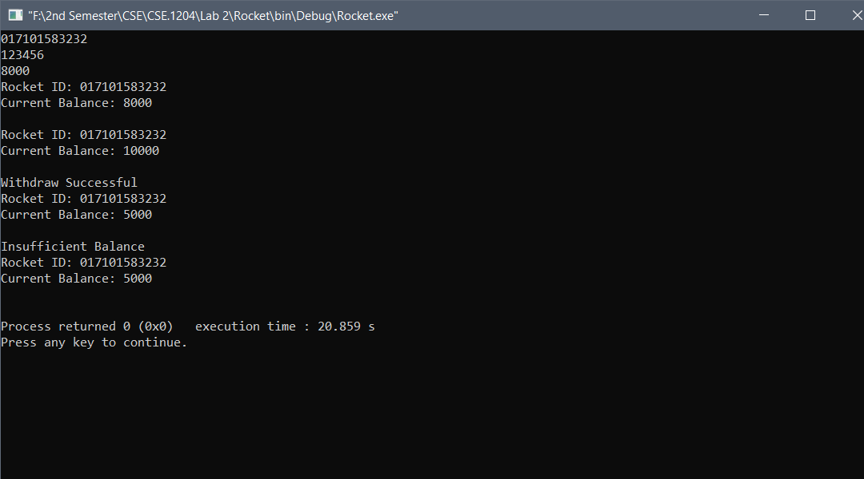**Output:**

**Conclusion :** By using my knowledge about C and C++, I completed the program.

**# The End #**